# Week 4.3

## Scene

The responsibilities of the scene is to

* Maintain a collection of game objects that are contained in the scene
* Allow game objects to be added to the scene
* Allow game objects to be removed from scene
* Initialize all game objects in the scene
* Update all game objects in the scene
* Draw all game objects in the scene
* Allow for a 2D UI to be drawn
* Check if the scene contains a specific type of game object
* Allow for a game object to be retrieved from the scene (multiple methods to do this)
* Allow for a specific component to be retrieved from a specific game object

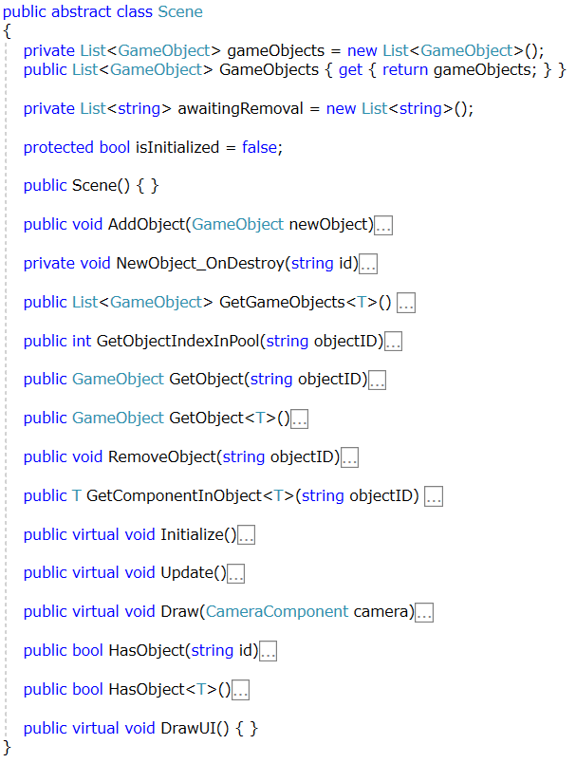

# MEthods

## Add object

* Set the Scene property of the new game object to be the current scene
* If the scene is already initialized, call initialize on the new game object
* Add an event handler to the OnDestroy event of the new game object
* Add the new game object to the collection of game objects

## Initialize

* Initialize each game object in the scene
* Set isInitialized of the scene to be true

## Update

* Update every game object in the scene
* Call remove object for any game object whose ID is in the awaiting removal collection
* Clear the awaiting removal collection

## Draw (Camera Component)

* Call Draw on all game objects

## Draw UI

* Virtual method with no implementation

## Has Object (String)

* Return a Boolean indicating whether the scene contains an object with the matching ID

## Has Object (T)

* Return a Boolean indicating whether the scene contains an object with the matching type

## Get Object Index (string)

* Find the game object with the matching ID and return it’s index in the game object collection
* If the object is not found, return -1

## Get Object (string)

* Return the game object with the matching ID
* Return null if it cannot be found

## Get Object (T)

* Return the game object with matching type

## Get Game Objects (T)

* Return all game objects with the matching type

## Get Component in Game Object (String) (Generic)

* Get the game object with matching ID
* If the component has the matching type (T) then return it
* If the component is not present in the game object then return null